2201AI47 Ankit Singh

- What is a Wireshark display filter, and how is it used?

- It is a bar above the column display where you type expressions to filter your view of network traffic.

- How would you write a display filter to show only packets coming from a specific IP address, such as 192.168.1.1?

- ip.src == 192.168.1.1 in the display filter bar and it will display the packets coming only from the source 192.16.1.1
- ip.dst == 192.168.1. – it will display the packets coming to destination 192.16.1.1
- ip.addr == 192.168.1.1 – either the source is given ip or the destination is ip

- Write a display filter to show only HTTP traffic.

- Filter : http
- Write http in the display filter bar and hit enter it will display only the http traffic
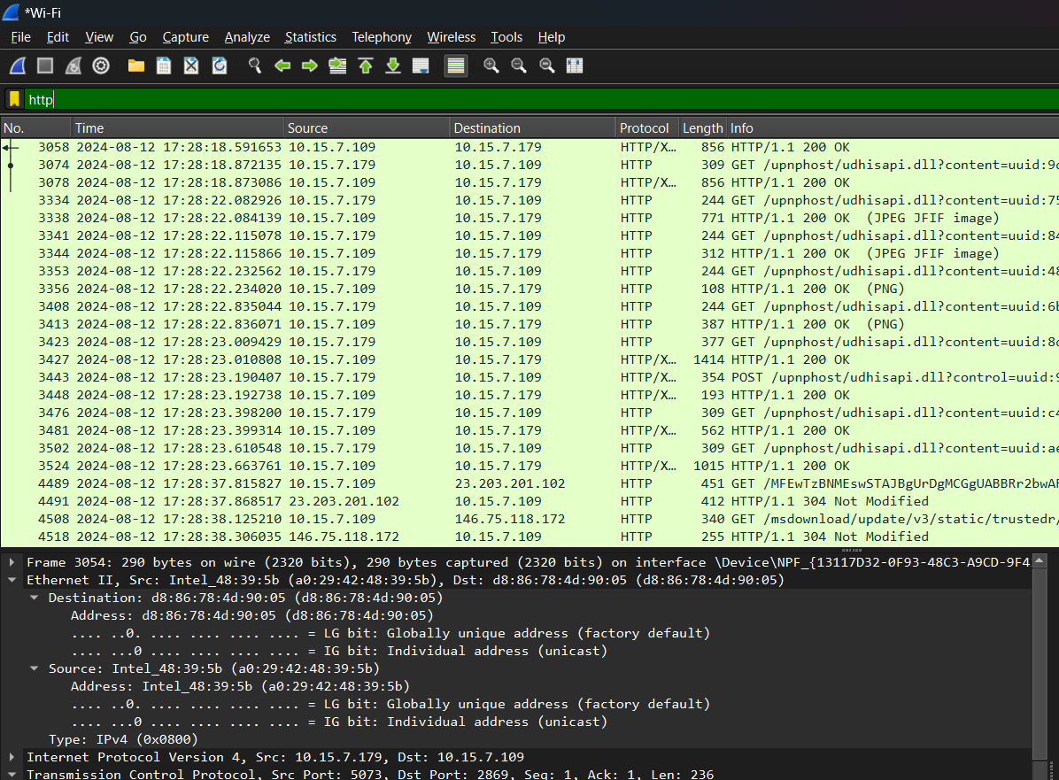

- How can you filter packets to show only those with a specific TCP port, such as port 443?

- Choose one packet
- Go to TCP details
- Right Click on the TCP port
- Select apply as filter and
- Click selected
- Filter will get set in the bar
- Filter : tcp.srcport == 443

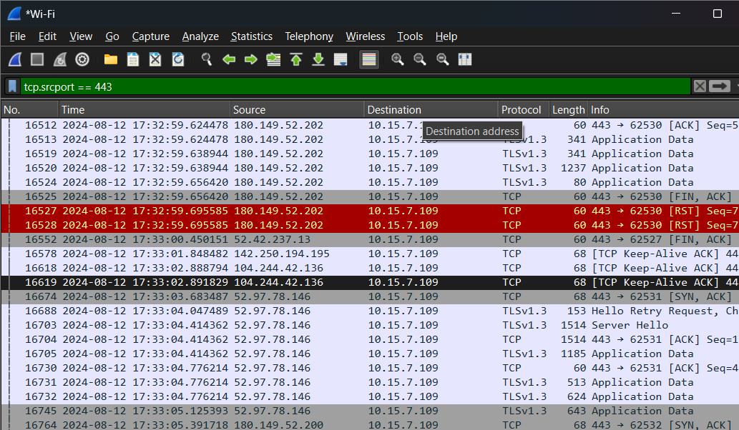

- What display filter would you use to show only DNS traffic?
- Use dns in the display filter bar
- Filter : dns

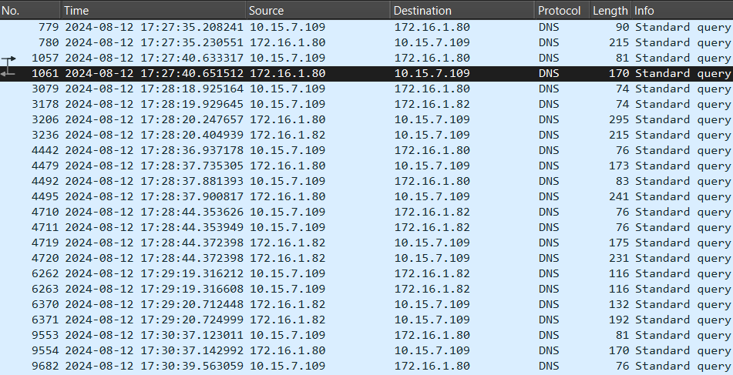

- How do you filter packets to display only those with a specific MAC address, such as `00:11:22:33:44:55`?

- Filter : eth.addr == 30:86:2d:61:47:5f
- FOR GIVEN EXAMPLE : eth.addr == 00:11:22:33:44:55

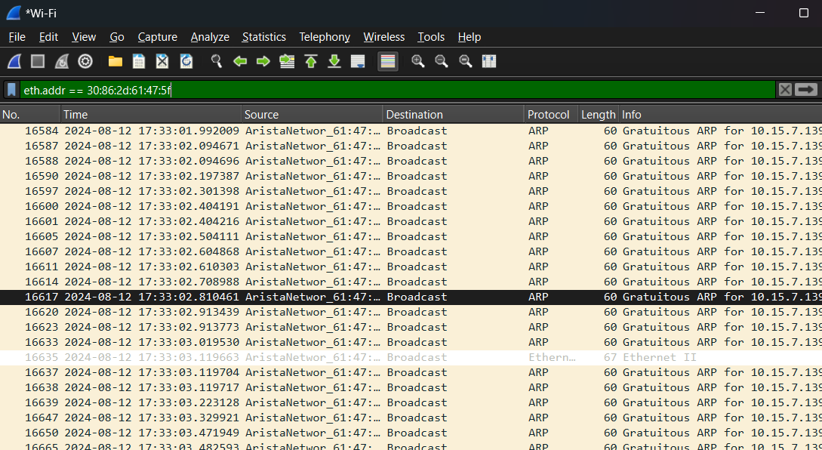

- Write a display filter to show only packets where the destination IP address is `10.0.0.1`.

- Filter : ip.dst == 10.0.0.1

- How can you filter packets to display only those using the UDP protocol?
- Filter : udp
- Use udp in the display filter bar

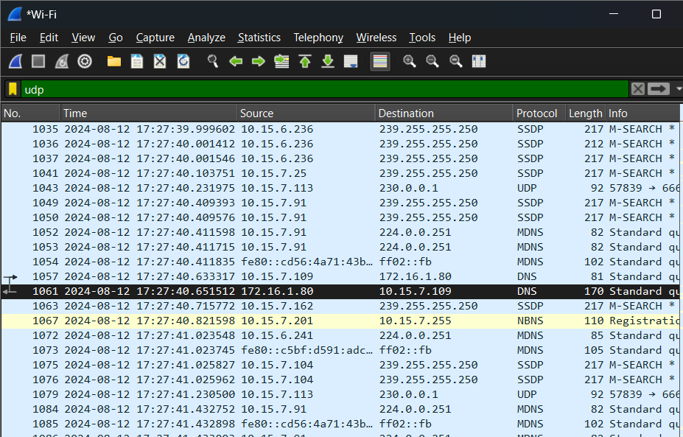

- What filter would you use to show only ICMP (ping) packets?
- Filter : icmp
- USE filter icmp

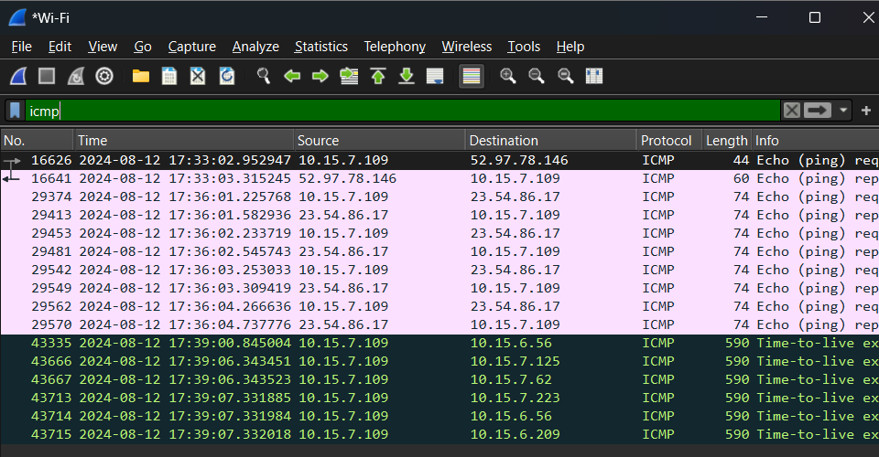

- Write a display filter to show only packets that are part of an established TCP connection.
- Filter : tcp
- Use filter tcp

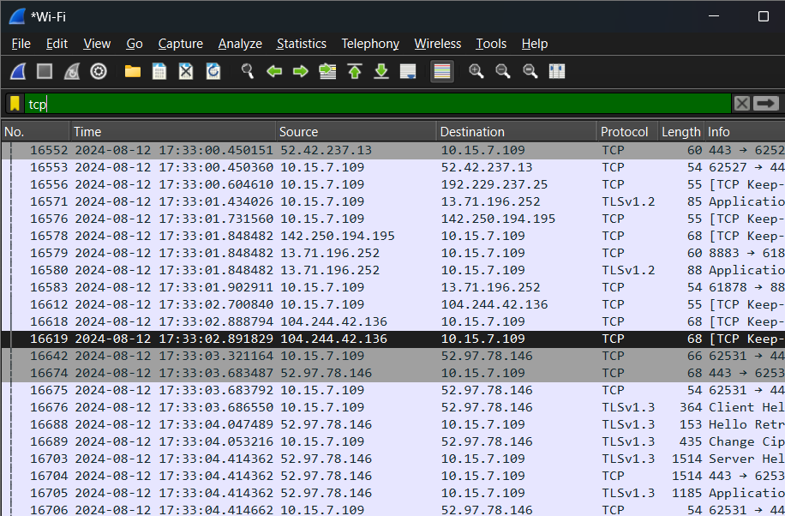

- How do you filter packets to show only those containing the word "login" in the HTTP request?

- Filter : http contains "login"

- What filter would you use to show only packets from a specific subnet, such as `192.168.1.0/24`?

- Filter : ip.addr == 192.168.1.0/24

- Write a display filter to show only packets that have been retransmitted.

- Filter : tcp.analysis.retransmission
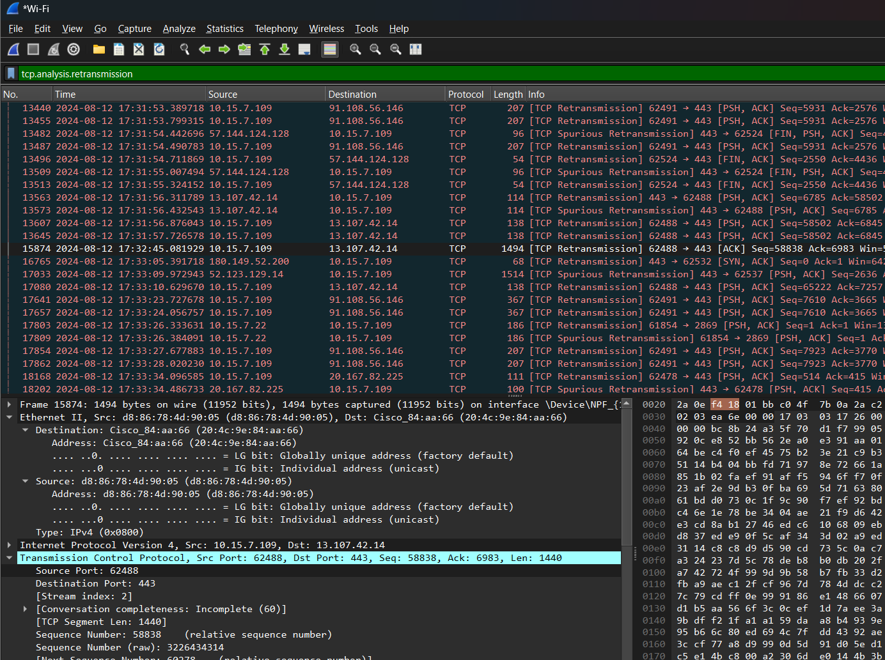

- How would you filter packets to show only those containing the ARP protocol?

- Filter : arp

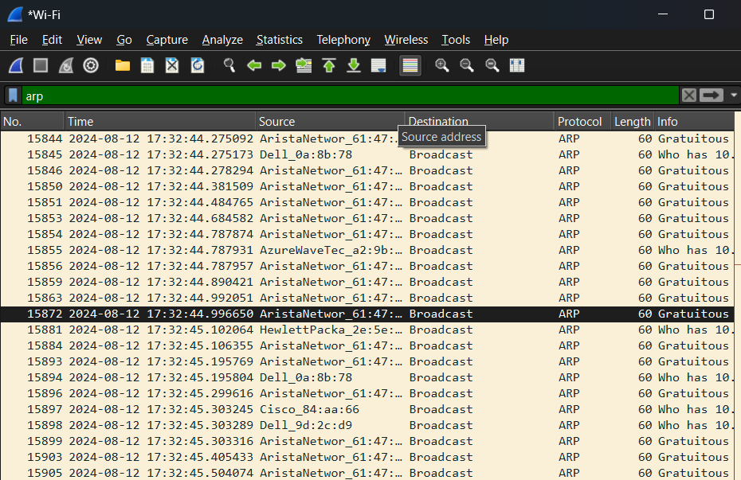

- What display filter would you use to show only SSL/TLS traffic?
- Filter : tls

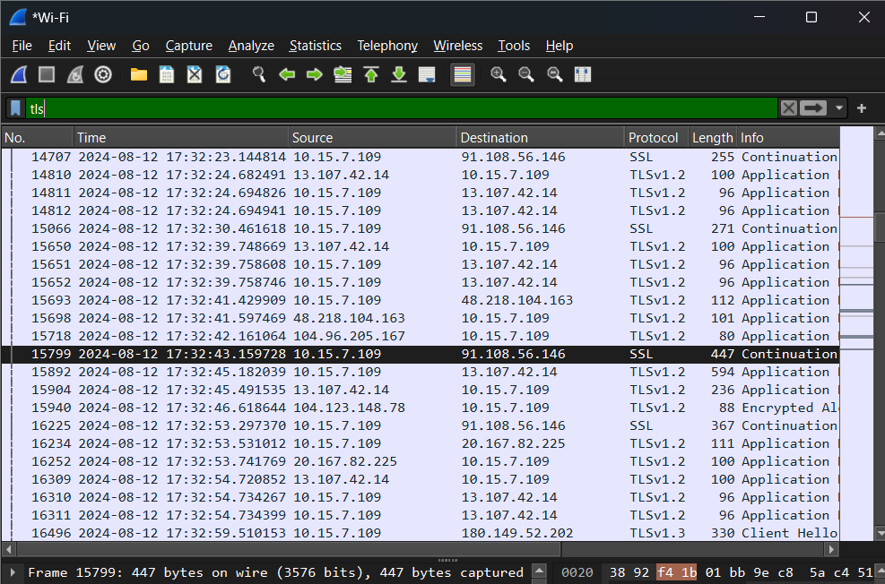

- List the different protocols that appear in the protocol column in the unfiltered packet-listing window in wireshark GUI
- Ethernet
- IPV (Internet Protocol Version)
- TCP ( Transmission Control Protocol )
- ARP
- ICMP
- UDP
- HTTPS
- HTTP
- DNS
- FTP
- SMTP
- POP3
- DHCP
- SSH
- TLS
- SSL

- How long did it take from when the HTTP GET message was sent until the HTTP OK reply was received for the webpage you visited in your web browser? (By default, the value of the Time column in the packetlisting window is the amount of time, in seconds, since Wireshark tracing began. To display the Time field in time-of-day format, select the Wireshark View pull down menu, then select Time Display Format, then select Time-of-day.)
- Filter : http

- 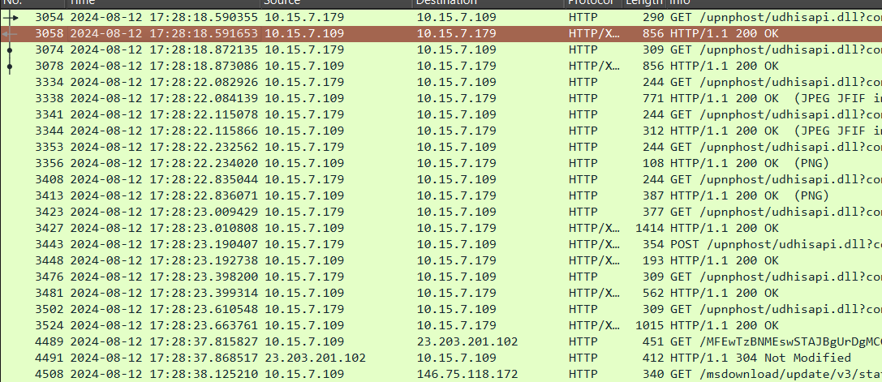

- View>> Time Display Format >> Date And Time of day

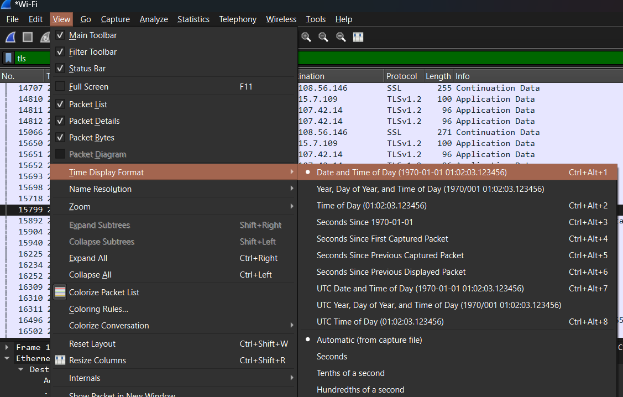

- This will display the time when the HTTP GET message was sent and the HTTP OK reply was received for the webpage visited in web browser

- What is the Internet (IP) address of the URL you visited and what is the Internet address of your computer?

- IP address of website visited can be found by ping command
- IP of website visited is : 23.54.86.17 (axisbank.com)

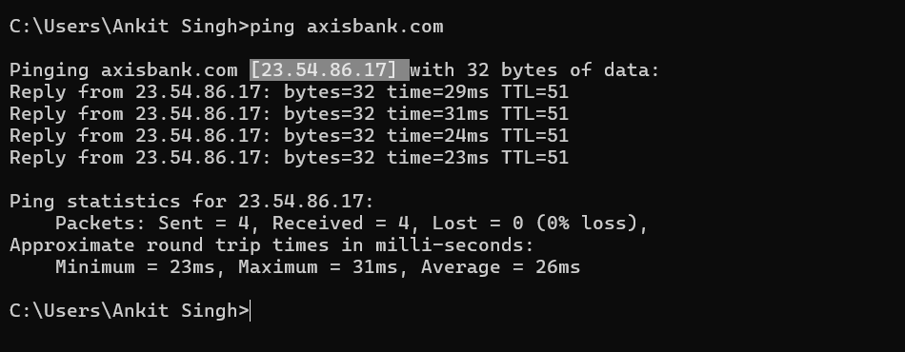

- Internet address of my pc can be found using ipconfig
- MY Internet address is : 10.37.0.241

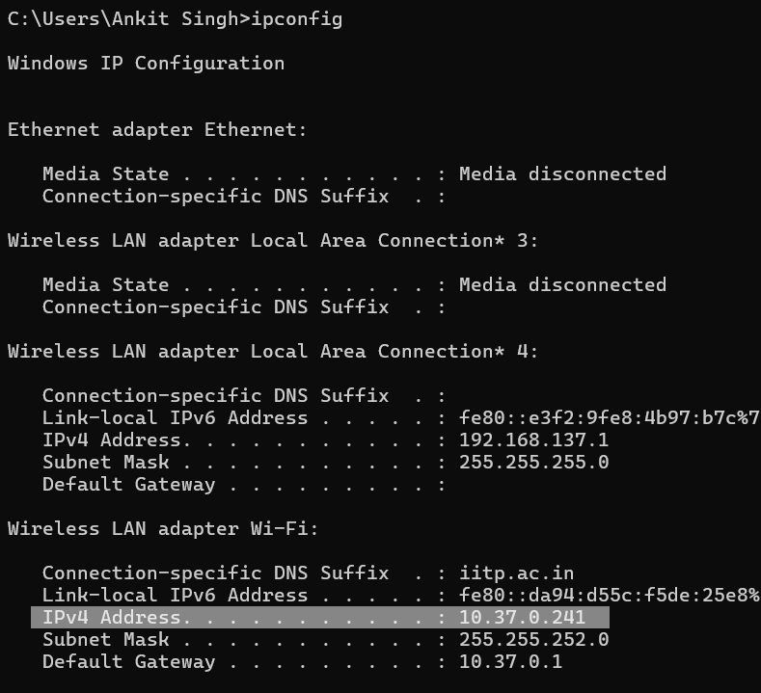

- Print the two HTTP messages displayed in wireshark GUI after you had visited above URL through your web browser. To do so, select Print from the Wireshark File command menu, and select “Selected Packet Only” and “Print as displayed” and then click OK.
- Filter Used: http
- Go to file menu
- Select Print >> Selected Packet Only
- Click OK to print
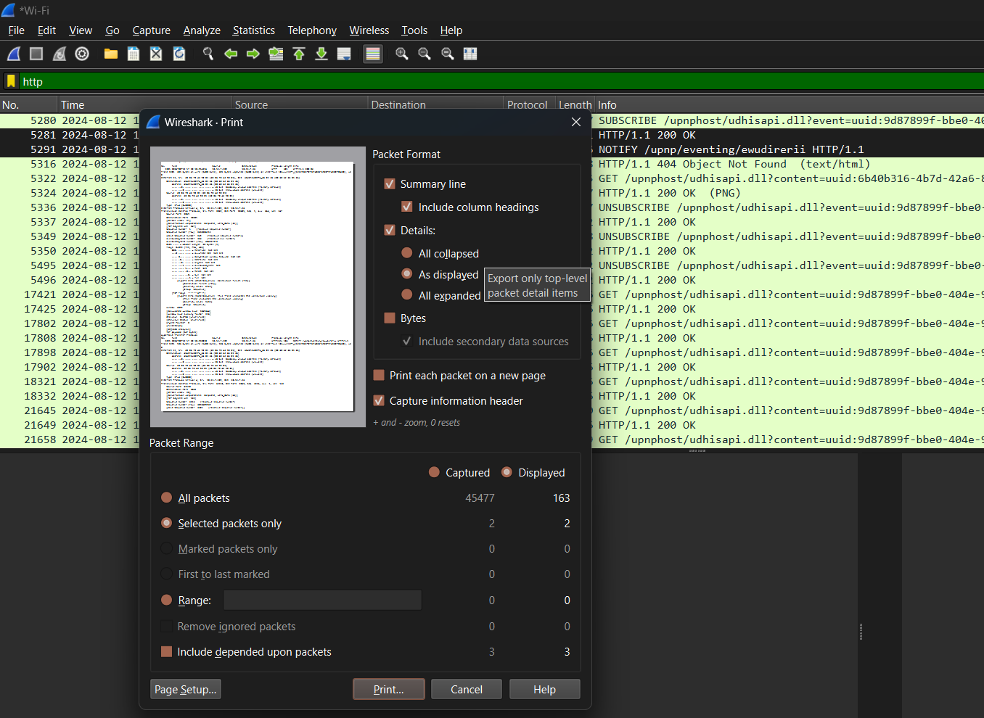

- Capture three way handshake for the following link:

Filter :
(tcp.flags.syn ==1 || (tcp.flags.syn == 1 && tcp.flags.ack==1 ) || (tcp.flags.ack==1 && tcp.flags.syn==0 && tcp.seq == 1 )) && ip.addr ==23.54.86.17

